Place for digital. sign of Revisor
Place for digital. sign of Contractor

00 | First issue | Antonio Aleksić | Grga Kolić | Zvonimir Lažeta |  | 17.8.2026.
Rev. | Revision Description | Created by | Checked by | Approved by Designer | Approved by Contractor | Date
Document Nr (CSD) PER-E-2-U5-MAN-002-00-VHHR

Employer:   | Consultant:   |   Contractor:  VOITH HYDRO GmbH&CoKG,  St. Pölten
Project:
Reconstruction and Modernisation
of HPP Perućica - Phase II
Title:
Unit 5 turbine governor cubicle - Operating and maintenance manual
  Designer: | Document No.: | Designer's No.:
 | PERU-01-15-111-70-002 | 22044-DD-EE-02-05-401

Table of contents
1 Turbine governor cubicle 3
1.1 Equipment overview 3
1.1.1 Control system devices 9
1.2 Turbine and auxiliary systems control 11
1.2.1 Start diagram – manual mode 11
1.2.2 Start diagram – automatic mode 15
1.2.3 HPP online 19
1.2.3.1 Turbine flow control 19
1.2.3.2 Active power control 19
1.2.3.3 Turbine speed control 19
1.2.4 Normal shutdown 20
1.2.5 Quick shutdown 22
1.2.6 Emergency shutdown 24
1.2.7 Partial stop 26
1.3 Monitoring and security 27
1.3.1 Emergency shutdown circuit 27
1.3.2 Maintenance 28

Turbine governor cubicle
Turbine governor cubicle is used for turbine control, protection and monitoring. Turbine control includes nozzles and deflector control (position control) as well as power control in the parallel operation and speed control in off-load operation and in isolated grid operation.

Equipment overview
Figure 1.1 shows the +U5CBC10 cubicle door layout while Table 1.1 contains its elements and their brief description.

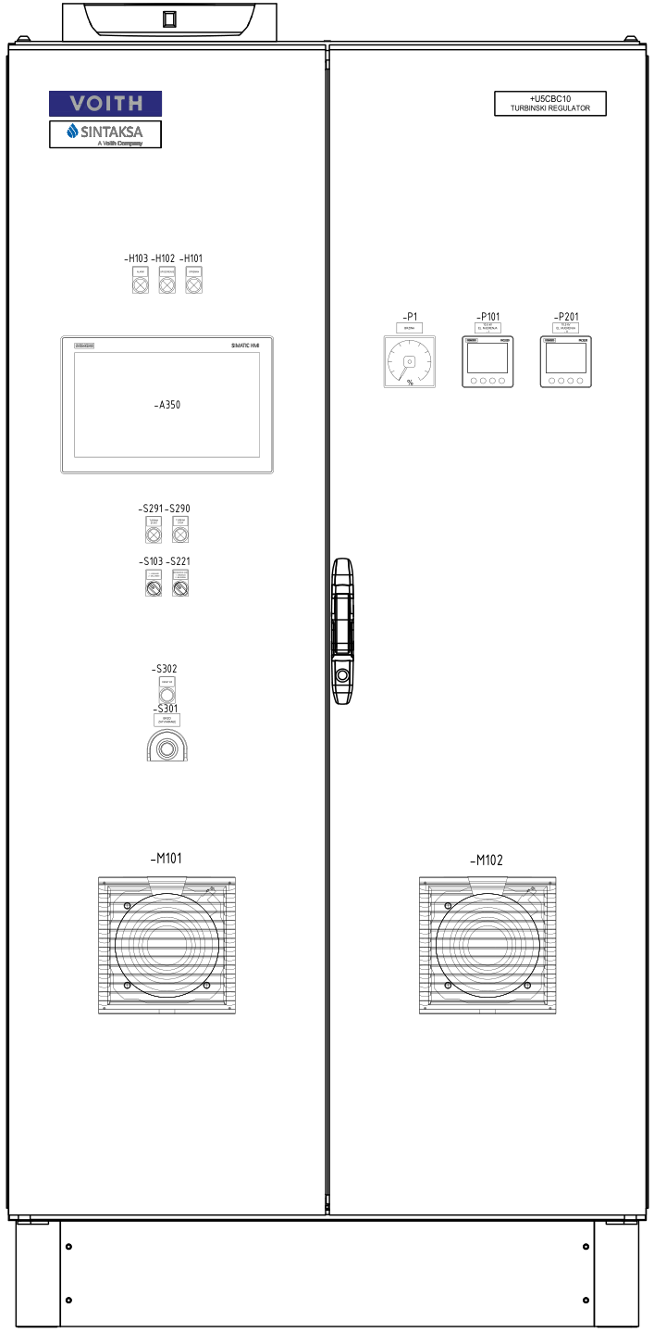
Figure 1.1. +U5CBC10 cubicle door layout
Table 1.1 Cubicles outdoor elements
Label | Name | Description
-A350 | Operating panel (HMI) | This HMI device allows operator to change parameters and to monitor and control the entire process. It also indicates warnings and errors when they occur.
-P1 | Analog panel meter | Analog panel meter is a type of panel meter that measures electrical parameters and displays them using a moving needle or pointer on a dial. Scale of P1 is 0-200%.
-H103 | Indication lamp – ALARM indication | The red indication light lights up if any alarms which cause an emergency shutdown occurs.
-H102 | Indication lamp – WARNING indication | The yellow indication light lights up if any alarm is active.
-H101 | Indication lamp – READY FOR AUTO START indication | The white indication light lights up when all conditions for starting the HPP in automatic mode are fulfilled.
-S291 | Pushbutton with indication – START | When all conditions are fulfilled, this pushbutton is used to start HPP in automatic mode.
-S290 | Pushbutton with indication – STOP | The pushbutton is used to stop HPP in automatic and manual mode.
-S103 | 2 position switch:  Local – Remote | Switch positions:  - Local – Local control mode is activated. Turbine governor system receives commands and setpoints from operator via operating panel.  Remote – Remote control mode is activated. Turbine governor system receives commands and setpoints from superior control system or from operator by SCADA.
-S221 | 2 position switch:  Enable – Block | Switch positions:  Enable – the mechanical braking system is enabled.  Block – the mechanical braking system is blocked.
-S301 | Pushbutton with indication – Emergency shutdown | This “mushroom” pushbutton is used to initiate emergency shutdown of the HPP. The red indication light lights up when the emergency shutdown is active.
-S302 | Pushbutton – RESET | The reset pushbutton is used to reset alarm conditions after eliminating all faults on the HPP.
-P101 | Measuring device – main  Sentron PAC 3220 | A measuring device used for electrical measurements.
-P201 | Measuring device – backup  Sentron PAC 3220 | A measuring device used for electrical measurements.
-M101,  -M102 | Cooling fans | Cooling fans cool the air inside the cubicle to increase the life expectancy of the devices inside of the cubicle.
* All Sentron PAC 3220 measurements are described in “HMI Operating panel manual”.

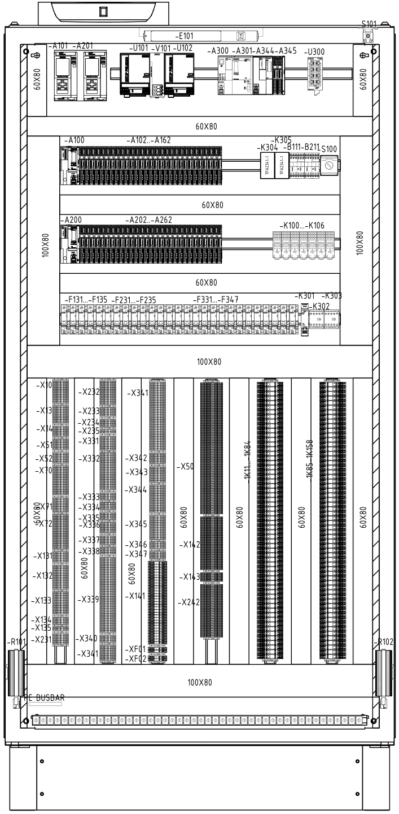
Figure 1.2. +U5CBC10 cubicle inside layout – front view

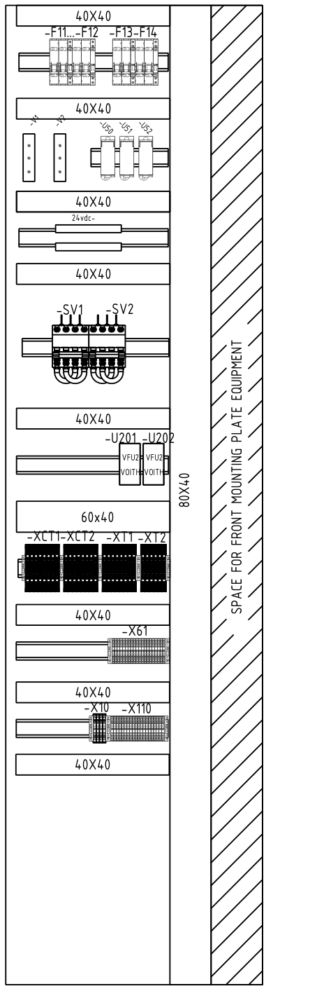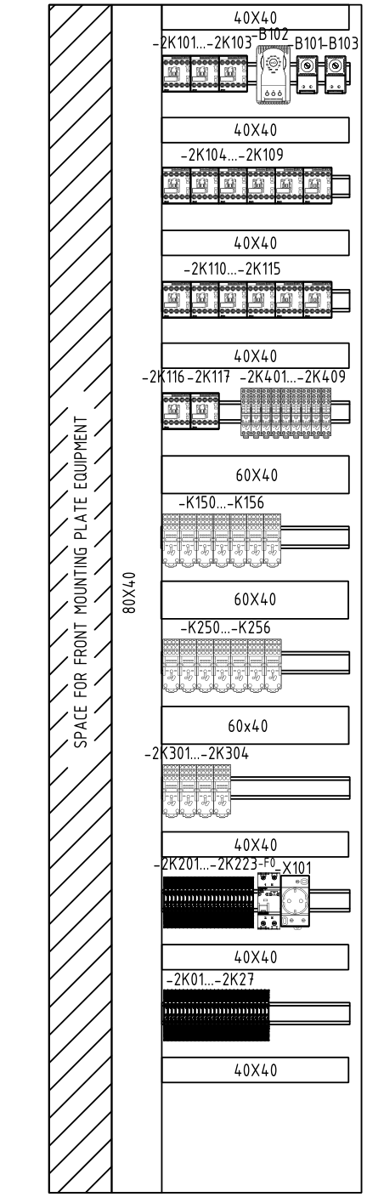
Figure 1.3. +U5CBC10 cubicle inside layout – side view

Table 1.2 Indoor cubicles elements
Label | Name | Description
-A100, …,  -A162 | PLC (Programable logic controller) - main | The PLC device is used to monitor, control and protect the HPP.
-A200, …,  -A262 | PLC (Programable logic controller) - backup | The PLC device is used to monitor, control and protect the HPP.
-A300, …,  -A345 | PLC (Programable logic controller) – Common PLC | The PLC device is used to monitor, control and protect the HPP.
-S100 | 2 position switch:  Service – Normal  operation | Switch positions:  - Service – Service mode is selected. It disables all HPP subsystems.  Normal operation – Enables normal operation of HPP.
-S101 | Door contact | Switches turn on the service lights when cubicle doors are opened. The -S101 switch turns on the -E101 light.
-E101 | LED lights with on / off switch | Service light used to illuminate interior cubicles.
-U101,  -U102 | Power supply unit | Converts mains DC (220V) to low voltage regulated DC (24V) power.
-V101 | Redundancy module | Device that decouples parallel-switched power supplies.
-U300 | Industrial Ethernet switch | Links all the devices into one local network.
-B102 | Hygrostat | The device is used for setting relative air humidity value inside the cubicle above which the heaters will switch ON.
-B101,  -B103 | Thermostat | The device is used for setting the air temperature value inside the cubicle under which the heaters will switch on. -B101 is used for heating, while -B103 is used for ventilation.
-F131, …,  -F135,  -F231, …,  -F235,  -F331, …,  -F347 | 1-pole circuit breaker | If overload or short circuit occurs, breaker will trip. They are equipped with auxiliary contacts.
-K301 | Safety relay | Relay with 3 NO contacts and 1 NC contact.
-K302,  -K303 | Contactor relay | Devices used to interrupt or establish connections in an electrical circuit repeatedly.
-X… | Terminals | Terminals for connecting wires and cables.
-1K…,  -2K01, …,  -2K36 | Auxiliary relay | The relays are used for galvanic isolation between the PLC input/output modules and the field signals or for the relay logic circuits inside of the cubicle (i.e. emergency stop circuit).
-F11, …,  -F14 | 2-pole circuit breaker | If overload or short circuit occurs, breaker will trip. They are equipped with auxiliary contacts.
-V1, -V2 | Diodes | Semiconductor device with two terminals, allowing current to flow in one direction only.
-U50,  -U51,  -U52 | Distribution block | A distribution block is used for distributing an electrical circuit from a single input source to several devices in the branch circuit.
-SV1,  -SV2 | Switch disconnector | Disconnector breaks the electrical circuit.
-U201,  -U202 | Frequency converter | Frequency converter with electrical isolation for measuring the speed from the residual voltage of the generator in  connection with a speed transducer.
-XCT1,  -XCT2,  -XT1,  -XT2 | Terminal block | Test disconnect terminal block.
-2K101, …,  -2K119 | Contactor relay | Coupling contactor relay with 4 NO contact.
-2K401,  ..,2K409,  -K150,  …,K159,  -K160,  …,K163,  -K250,  …,K255,  -K256,  …,K263,  -2K301,  …,2K306 | Miniature plug-in relay | The relays are used for galvanic isolation between the PLC output modules and the field signals or for the relay logic circuits inside of the cubicle.
-2K201,…,  -2K224 | Timer relay | It is also called a time-delay relay. It is a device that controls the timing of an event. It opens or closes contacts after a pre-determined amount of time has elapsed, providing a timed control function.
-F0 | Residual current circuit breaker (RCBO) | Safety devices with overcurrent protection that interrupts an electrical circuit when an imbalance is detected.
-X101 | Socket - outlet | Auxiliary socket.
-B111, -B211 | Rotational speed monitoring device | The device receives pulses from inductive probe inside the generator and calculates the rotational speed of the generator. The calculated generator speed is sent to the PLC via an analog signal (4-20mA). It also initiates emergency shutdown if the generator speed is above predefined value.
-R101,  -R102 | Cubicle heaters | Heaters heat the air inside the cubicle to increase the life expectancy of the devices inside of the cubicle.

Control system devices
In this chapter the operating functions, modes and parameters of the devices inside the cubicles will be described.

-2K201, …,-2K224 – Timer relays – these relays are used to switch between main and backup PLC rack, TOFF relays keep the outputs in normal operation and should remain in 1.

-A100, …, -A345 – PLC – The configuration of this device is modular and different for each power plant. In each of its operating cycles, the device first determines the state of the process and checks for a fault by reading digital and analog inputs. If there are no active alarm states, its algorithm is used to determine further actions performed by the device digital and analog outputs and communication protocols. If any alarm state is active, it notifies the operator by displaying alarms on the operating panel and initiating unit shutdown if necessary. For better insight of the state of the process, the flow of information can be established with other devices of the control system using a specific communication protocol. Different PLC models with appropriate modules can be used. A detailed device description can be found in the manufacturer operating manual.

-B101 – Thermostat – Used thermostat is Alfa Electric THR2. By switching on the dry contact 1-2, cubicle heaters are switched on. The temperature setpoint for switching contact on and off can be changed with the potentiometer on the front side of the device. Initially the setpoint is set between 15°C and 20°C. A detailed device description can be found in manufacturer operating manuals.

-B102 – Hygrostat – Used hygrostat is FANDIS IGR35F HYGROSTAT. By switching on the dry contact N01-C01, cubicle heaters are switched on. The device is initially set to operate with relative air humidity setpoint between 60% and 65%. The power supply of the device is connected to 4 and 5 contacts, while contacts 1 and 2 are used to switch the heater on and off to maintain air temperature at the temperature defined on the potentiometer. A detailed devices description can be found in manufacturer operating manual.

-B111, -B211 – Rotational speed monitoring device – IFM DD2503 device is used to measure the generator rotational speed. It receives pulses from the inductive probe inside the generator and calculates the speed measurement. The speed measurement is transmitted with a current signal (4-20mA) to the PLC. Also, using one or both dry contacts, the overspeed signal is sent to the PLC and to the emergency shutdown circuit. A detailed device description can be found in manufacturer operating manual.

-P101, -P201 - Measuring device – VTs and CTs used to measure the voltage and current of the generator stator windings are connected to this device. The device measures generator voltages, currents, power, PF, THD, etc. Using the PROFINET or PROFIBUS communication protocol, the measurements are transmitted to the PLC and used for control and monitoring. Commonly used device is SENTRON PAC3220. A detailed device description can be found in manufacturer operating manual.

-U300 – Industrial ethernet switch – These devices are used to link the control system devices to the local network. Depending on HPP control system configuration, many different switches can be used.

Turbine and auxiliary systems control
Depending on the location and mode, there are different ways to control the process. Using selection on HMI panel, it is possible to switch between manual or automatic mode. Using the 2-position switch -S103, it is possible to select control location to local (HMI) or remote (SCADA).

When manual control is selected, an operator manually executes all commands and sets all setpoints required for proper operation of the unit. When automatic control is selected, the control system requires only start and stop commands as well as the setpoint for the desired operating mode of the unit. According to the commands, the control system performs all the actions necessary to keep the unit at the desired setpoint.

When local control is selected, the control system accepts commands and setpoints from the pushbuttons on the cubicle and from the operating panel. Otherwise, when remote control is selected, the control system accepts commands and setpoints from the common control system or from the SCADA.

WARNING: REMOTE CONTROL IS POSSIBLE ONLY IN AUTOMATIC MODE.

In this chapter, the unit control system is explained through flow diagrams and logic diagrams. For the purposes of this document, a Pelton turbine is described. Flow control diagrams can be different, depending on the configuration of the HPP and its subsystems. Detailed descriptions of all states, measurements, indications and actuators can be found in the “HMI operating panel manual”.

Start diagram – manual mode
For system operation in the manual mode, switch -S103 must be in the “Local” position and “Manual” mode must be selected on the HMI panel. To start the unit, there must be no alarm that causes starting interlock or shutdown, and the unit must be in standstill state. The flow diagram of the normal start in manual mode is shown in Figure 1.4.
The diagram shows usual way of starting the HPP. It is not necessary to strictly follow the steps in the presented order to manually start HPP.

Figure 1.4. Manual mode start flow diagram – process control as a block diagram

Sequence steps while starting in manual mode are following:

- UNIT IN STANDSTILL - The unit is in the standstill and control system is waiting for the starting conditions to be fulfilled.

- UNIT READY TO START - All starting conditions are fulfilled and the HPP is ready to start.

- CWS CONTROL – If CWS control is active, the CWS valve is opened. When the CWS water flow and pressure are within their operating values, the CWS is considered ready.

- LUB CONTROL – If the LUB control is active, the LUB oil pumps are switched on. If the LUB oil flow and pressure are within their operating values, the LUB is considered ready for running the turbine.

- HPU CONTROL – If the HPU pressure is below the operating value, the oil pumps will be activated. The control system maintains the HPU oil pressure within the rated values for regular operation.
- When the hydraulic power unit is ready for operation, it is possible to generate command for opening bypass valve. If the water pressure difference before and after MIV is below the threshold set in the parameters, it is possible to generate the command for MIV opening without opening the bypass valve.

- LOW TURBINE PRESSURE – During this step, bypass valve is opened to equalize the water pressure before and after the MIV. If the water pressure difference before and after MIV is below the threshold set in parameters, it is possible to skip this step.
- When the turbine water pressure rises above the threshold opening the MIV, it is possible to generate the command to release the MIV valve seal.

- MIV SEAL RELEASE – During this step the MIV valve seal is releasing. After this step, it is possible to open the MIV.

- TURBINE PRESSURE OK – During this step the MIV is opening. When the MIV is fully open, it is possible to proceed to the next step.
- After the MIV is open, it is necessary to generate a command to close the bypass valve.

- BYPASS OPEN; MIV OPEN – During this step, the bypass valve is closing. When the bypass valve is fully closed, it is possible to proceed to the next step.
- After closing the bypass valve, it is possible to open the turbine nozzles and deflector.
- BYPASS CLOSED; MIV OPEN – Commands for deflector and synchronization nozzle control can be activated. Hydraulic deflector control valves and nozzles with active control are energized. If one of the nozzles control is active during this step, that nozzle is considered as synchronization nozzle. The synchronization nozzle can be manipulated only when HPP is offline.
- Control of the opening of synchronization nozzle determines the amount of water flowing through the turbine. The deflector position control determines the angle between the runner blades and the water flow. It is necessary to achieve the synchronization speed of the generator. When the turbine starts running, the control system proceeds to the next step.

- TURBINE CONTROL – The turbine control is activated and unit speed rises. It is possible to select different types of control: turbine speed control, synchronization nozzle and deflector cylinders positions control or cylinders opening/closing speed control. If turbine speed control is selected, the position of the synchronization nozzle cylinders remains the same as when the turbine speed controller is switched on, which controls the speed only by using deflector cylinder.
- When the unit total speed rises over excitation speed relay threshold, it is necessary to set a command, via the operating panel, to activate the generator voltage controller.
- PROCESS CONTROL – In this part, the turbine regulation waits for the unit process control system to start the excitation and synchronization. After the GCB is closed in the process of synchronization, turbine governor system proceeds to the next step.

- HPP ONLINE – Initial preselected controller (selected in the parameters) is activated. A detailed
description of the online HPP control can be found in Chapter 1.2.3

Start diagram – automatic mode
To operate the unit in automatic mode, “Automatic” mode must be selected on the HMI panel. Depending on the desired control location, the -S103 switch can be set to “Local” or “Remote”. If remote control is selected, the control system receives commands and setpoints from common control system or SCADA. If “Local” control is selected, the control system receives commands and setpoints from the operating panel, switches and pushbuttons on the cubicle. To start the unit, there must be no alarm that causes starting interlock or shutdown (List of alarm states and their description can be found in the “HMI operating panel manual”) and the generator must be in standstill state. The flow diagram of the normal start in automatic mode is shown on Figure 1.5.

Figure 1.5. Automatic mode start flow diagram – process control as a block diagram

Sequence steps while starting in automatic mode are following:

- UNIT IN STANDSTILL - the unit is in standstill and there is no active start command.
- Either by pressing the START button, or by the operating panel on the + U5CBC10 cubicle door when local control is selected, or by the superior system when the remote control is selected, with all start conditions fulfilled, the start sequence for normal start in automatic mode is activated.

- CWS CONTROL – After activating CWS control, the CWS valve is opened.
  - When the CWS water pressure and flow are within their operating values, the CWS is considered ready and the control system proceeds to the next step.

- LUB CONTROL – When the CWS is ready, the LUB control is activated and the LUB oil pump is switched on.
  - When the LUB oil pressure and flow are within their operating values, the LUB is considered ready and the control system proceeds to the next step.

- HPU CONTROL – HPU control is activated. If the HPU pressure is below the operating value, the oil pump will be activated. The control system maintains hydraulic power unit oil pressure within the rated values for regular operation.
- When the HPU accumulator oil pressure is within its nominal values, the HPU is considered ready.

- LOW TURBINE PRESSURE – During this step, a bypass valve is opened to equalize the water pressure before and after the MIV. If the water pressure difference before and after the MIV is below the threshold set in parameters, this step is skipped and the control system proceeds to “MIV seal release” step.
- When the turbine water pressure rises above the threshold for opening the MIV, it is possible to generate the command to release the MIV valve seal.

- MIV SEAL RELEASE – During this step the MIV valve seal is releasing. After this step, it is possible to open the MIV.

- TURBINE PRESSURE OK – This step starts by generating a command to open the MIV.
- Once the MIV is open, the control system proceeds to the next step.

- BYPASS OPEN; MIV OPEN – This step starts by generating a command to close the bypass. If the bypass valve is closed at the time when the MIV is fully open, this step is skipped.
- After closing the bypass valve, it is possible to run the turbine.

- BYPASS CLOSED; MIV OPEN – When the control system reaches this step, it opens the synchronization nozzle and deflector in open loop control. There are 3 sets of synchronization nozzle and deflector position setpoints (set in parameters) that are used while turbine speed is below a certain threshold set for each set of parameters.
- After the turbine speed reaches the last speed threshold, the control system proceeds to the next step.

- TURBINE CONTROL – In this step, the turbine speed controller is activated and the control system starts to increase turbine speed to the nominal value.
- When the unit speed increases over excitation speed relay threshold, the unit process control system starts the excitation and synchronization process. After GCB is closed, the turbine governor system proceeds to the next step.

- HPP ONLINE – Initial preselected controller (selected in the parameters) is activated. A detailed description of the online HPP control can be found in Chapter 1.2.3.

HPP online
Once the unit is online, various operating modes and controls can be selected to keep the unit at the desired operating point.

Turbine flow control

Turbine flow control is a control in which the controller reaches and maintains the desired turbine flow setpoint. The desired turbine flow setpoint is set by the operator using the HMI panel or SCADA. There are two ways in which it is possible to control the turbine flow. One way is for the operator to enter a setpoint for each turbine actuator separately. Example:
- separate distributor setpoint, separate runner setpoint (Kaplan turbine)
- separate setpoint for each nozzle (Pelton turbine)
Each turbine actuator has a separate position controller that receives the desired setpoint and cylinder position measurement as input, and acts on the hydraulic cylinder of that actuator.
Another way to control the turbine flow is for the operator to enter the desired setpoint for the total turbine flow. In that case the setpoint distributor will calculate separate setpoint for each turbine actuator.

Active power control

Active power control is a control in which the controller reaches and maintains the desired active power setpoint. The desired active power setpoint is set by the operator using the HMI panel or SCADA. The active power setpoint and active power measurement are inputs for the power controller which reaches the desired active power setpoint by adjusting the turbine flow. That means the active power controller is the superior controller to the:
- distributor and runner position controller (Kaplan turbine),
- nozzles (Pelton turbine)
- distributor (Francis turbine).

Turbine speed control

Turbine speed control is a control in which the controller reaches and maintains the desired turbine speed setpoint. The desired turbine speed setpoint is set by the operator using the HMI panel or SCADA. The speed setpoint and speed measurement are inputs for the speed controller which reaches the desired speed setpoint by adjusting the turbine flow (Kaplan and Francis turbines) or by adjusting the deflector position (Pelton turbine).

Normal shutdown

Flow chart of normal shutdown is shown in Figure 1.6.

Figure 1.6. Normal shutdown flow diagram

Sequence steps during normal shutdown of the unit are:

- HPP ONLINE – GCB is closed and the generator produces electrical energy.
  - By pressing the “Stop” pushbutton on the left door of the “Turbine governor” cubicle or “STOP HPP” button on the operating panel when local control is selected or by receiving the “Stop” command from superior control system when the remote control is selected, the stop command is generated.

- MINIMAL ACTIVE POWER – When the HPP stop command is generated, all nozzles start to close with closing speed determined by parameters.
  - The sequence continues when the generator active power falls below the generator active power limit set to open the generator circuit breaker.

- NO LOAD – When the active power threshold for switching off the generator circuit breaker is reached, a command to switch generator circuit breaker off is generated.
  - When the generator circuit breaker is open, the sequence continues.

- CLOSING TURBINE – Commands for switching off the automatic voltage regulator and closing the deflector, MIV and disabling the GCB are generated. The turbine slows down and service valve is switched off.
  - To proceed to the next step, the turbine speed must be below the threshold set to activate the brake, the water flow must not pass through the turbine runner.

- ENGAGE MIV A AND MIV B SEALS – During this step the MIV valve seals are releasing. After this step, it is possible to proceed to the next step and generate the braking command.

- BRAKING – A command for braking is generated.
  - To proceed to the next step, the turbine speed must be below threshold below which is considered that turbine is in standstill.

- UNIT IN STANDSTILL – Commands for turning off the hydraulic power unit (HPU), turning off the lubrication oil unit (LUB), turning off the cooling water system (CWS) and closing of isolation valve.
  - To proceed to the next step, all start conditions must be fulfilled.

- READY FOR RESTART – The control system is waiting for the start command.

Quick shutdown

Quick shutdown is a sequence with the priority to bring a HPP to a standstill as soon as possible due to a fault. The speed of the unit must not increase above the speed at the time of the fault, otherwise the fault could get worse and severe mechanical damage may occur. Quick shutdown can be activated regardless of the operating mode of the HPP. It can be activated by certain alarm states or by superior control system. Flow chart of quick shutdown is shown in Figure 1.7.

Figure 1.7. Quick shutdown flow diagram

The sequence steps during quick shutdown of the unit are:

- HPP online – The GCB is closed and the generator produces electrical energy.
  - A quick shutdown command is generated.

- MINIMAL ACTIVE POWER – All superior controllers are switched off, turbine nozzles and deflector are closed, and after they are closed the MIV is closed. In that way active power is reduced at the highest possible speed. Also, the service valve is switched off.
  - The sequence continues when the generator active power falls below the generator active power threshold set to open the generator circuit breaker.

- NO LOAD – The command to open the generator circuit breaker is generated.
  - The sequence continues when the generator circuit breaker is open.

- CLOSING TURBINE - Commands for turning off automatic voltage controller and disabling the GCB are generated.
  - To proceed to the next step, the turbine speed must be below the threshold for activating the brake, and the water flow must not pass through turbine runner.

- ENGAGE MIV A AND MIV B SEALS – During this step the MIV valve seals are releasing. After this step, it is possible to proceed to the next step and generate the braking command.

- BRAKING – A brake command is generated.
  - To proceed to the next step, the turbine speed must be below the threshold below which is considered that the turbine is in standstill.

- UNIT AT REST – Commands for turning off hydraulic power unit (HPU), turning off lubrication oil unit (LUB), turning off cooling water system (CWS) and closing of isolation valve are generated.
  - To proceed to the next step, all start conditions must be fulfilled.

- READY FOR RESTART – The control system is waiting for the start command.

Emergency shutdown

Emergency shutdown is a sequence with the priority to open the GCB and then bring the HPP to a standstill as soon as possible due to fault. Emergency shutdown can be activated regardless of the HPP operating mode. The flow diagram of the emergency shutdown of the unit is graphically shown in Figure 1.8

Figure 1.8. Electrical emergency shutdown flow diagram

Sequences during electrical emergency shutdown:

- HPP online – The GCB is closed and the generator produces electrical energy.
  - The electrical emergency shutdown command is generated when the system enters one of the alarm states from the alarms group that is causing electrical emergency shutdown. A list of alarm states that cause electrical emergency shutdown and their description can be found in the “HMI operating panel manual”.

- NO LOAD – Commands for switching off generator circuit breaker, switching off all superior controllers, switching service valve off and for closing all hydraulic cylinders is generated.
  - Sequence continues when the generator circuit breaker is open.

- ENGAGE MIV A AND MIV B SEALS – During this step the MIV valve seals are releasing. After this step, it is possible to proceed to the next step and generate the braking command.

- BRAKING – A brake command is generated.
  - To proceed to the next step, the turbine speed must fall below threshold under which it is considered that turbine is in standstill.

- UNIT IN STANDSTILL – Commands for closing the brake, switching off the hydraulic power unit (HPU), switching off the lubrication oil unit (LUB), switching off the cooling water system (CWS) and closing of isolation valve are generated.
  - To proceed to the next step, all of the start conditions must be fulfilled.

- READY FOR RESTART – The control system is waiting for a start command.

Partial stop

If the power supply grid fault has occurred and partial stop is enabled in the control parameters, a partial stop is initiated. The flow diagram of the partial stop is shown in Figure 1.9.

Figure 1.9. Partial stop flow diagram

The sequence steps during the partial stop are:

- HPP ONLINE – The GCB is closed and the generator produces electrical energy.
  - Partial stop is only initiated if the GCB is open and there is no alarm for ESD and QSD.

- NO LOAD – The unit is disconnected from the grid in no load state. Commands to close the turbine.
  - The control system waits until the unit speed start to decrease and get under the threshold for activating turbine control.

- TURBINE CONTROL – Turbine control is activated and the unit start sequence continues from this step. Further steps in manual and automatic control mode are already described in Chapter 1.2.1 and 1.2.2, respectively.

Monitoring and security
In order to ensure that all parts of the process are executed accurately and to manage that, in case of any fault, the process stops without any additional damage, it is necessary to have devices for monitoring, control and backup protection.

Emergency shutdown circuit

The emergency shutdown circuit is the main protection circuit in the unit control and protection system. It is the serial connection of the digital outputs of all devices with protection functions that energize ESD relays that open the generator circuit breaker and close all hydraulic cylinders when they are not energized. If any of the abovementioned electrical outputs opens emergency shutdown circuit, electrical emergency shutdown will be initiated. The elements of emergency shutdown circuit are:

- -S301 is the emergency shutdown pushbutton placed on left door of the +U5CBC10 cubicle. If a dangerous situation occurs, an operator can press this pushbutton and by pressing it he will open emergency shutdown circuit and initiate electrical emergency shutdown.
- -2K16 - if the relay 2K16 “PLC ALIVE” loses power, i.e. the digital output is at 0, the ESD branch will be turned off and an emergency shutdown will occur
- -2K01 - if it happens that the digital output of rack 1 or rack 2 "PLC ESD ACTIVE" is at 1, relay 2K01 will turn on and turn off the ESD branch
- -B111, -B211 - speed monitoring devices that detect an overspeed of the generator. When energised, it opens the emergency shutdown circuit.
- -S1 - the ESD pushbutton located in the control room
- There will be 2 pushbuttons on the unit process control cubicle - one for ESD, and the other for activating the CO2 battery in case of fire. Pressing either one of the pushbuttons stops the unit.
- -K30.1 – ESD activation from the PLC in unit process control

Maintenance

It is extremely important to periodically check the functionality of certain devices and control circuits that play a vital role in domains such as generator protection, measuring etc. Functionality check is an important aspect in maintenance. It is a safety precaution that can prevent major failures or major damages.

- Local signalization check – This test checks the functionality of the diode block and LED lights inside cubicles. Important signalizations depend on its functionality: “Warning”, “Failure”, “Ready for automatic start”, “GCB closed”, “GCB open” and “Fast stop”. When the switch named “Lamp test” located on the door of “Turbine governor” cubicle (-S203) is pressed, all diodes, if in function, should conduct causing all mentioned indications to turn on.

CAUTION: Testing and changing the device should be done only by authorized personnel.

- Emergency shutdown circuit – Each segment of the emergency shutdown circuit must be checked. Additionally, the relays from this circuit are tested mechanically by lifting the “test” lid. The contacts should close after lifting the lid.

- Speed measurement functionality – The speed measuring device (IFM) is tested before the departure of cubicles. In this test one PLC is used as a speed simulator. If there is a difference between the main and redundant speed measurement or a difference between speed and the generator frequency when unit is online, an alarm is triggered. If this device is changed, it is extremely important to set initial settings from the old device to the new one.
- Cubicle heater – High humidity can shorten the life expectancy of the equipment, so it is important that the -R101 and -R102 cubicle heaters work properly. Checking the functionality of the heaters is done by changing the setpoint values of air temperature on the thermostat -B101 and relative humidity on the hygrostat -B102. When air temperature inside the cubicle is below or relative air humidity is above the referent value, cubicle heaters should be switched on. Otherwise, they should be switched off. Before testing, it is important to mark the initial values set on thermostat and hygrostat and to set them back after the test is finished.

- Cubicle ventilation – Very high temperature can cause the failure of electrical devices. As such, careful scrutiny of climate control methods is critical to achieving long-term operational effectiveness of these systems. In this cubicle, filter cooling fans (dimensions 255 x 255 mm) are chosen. It is important that -M101 and -M102 cooling fans work properly. Checking the functionality of the cooling fans is done by changing the setpoint values of air temperature on the thermostat -B103. When air temperature inside the cubicle is above the referent value, cubicle cooling fans should be switched on. Otherwise, they should be switched off. Before testing, it is important to mark the initial values set on thermostat and to set them back after the test is finished.

Thermostat THR2, Thermostats User’s manual,, Doc. No: UMA-CTR-THXX-rev00, Alfa Electric.
IGR35F – HYGROSTAT CHANGE OVER, Datasheet, Fandis SpA.
Rotational speed monitor IFM DD2503, Doc. No.: 7390953, Date: 2013
Power Monitoring Device SENTRON PAC3220 Manual, Doc. No.: L1V30425208F-01, Date: 10.2019., Siemens.

